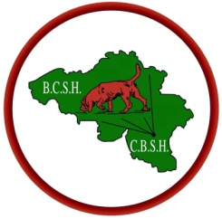
Belgische Club voor Sinthubertushonden
Club Belge des Chiens de Saint Hubert

ASBL – VZW - Lid K.M.S.H. – Membre S.R.C.S.H. - F.C.I. n°771 ASBL – VZW - Lid K.M.S.H.

39 th Speciality of the breed with CAC - On Saturday the 5 th September of 2026
in the citypark "Dussart" in Saint-Hubert

Judge: Mr. Rudy Smits (NL)

Judgements will begin at 10 AM Closing date: 23/08/26

Name of dog :
Dog : |  | Bitch: |  | Pedigree: |  |  | Colour:
Chip number:
Birthdate: |  |  | Title(s) :
Sir :
Dam:
Breeder(s):
Owner(s):
Adress
Adress | Postcode: |  |  |  | Town: |  |  | Country:
E-mail : |  |  |  |  |  | Tel:
Registration fees classes 1st dog: 30 €, 2nd dog :25 € , 3 rd dog : 20 €
Join pedigree Annual subscription: Belgium 26 € - Europ : 34 € ( inevitable)

Baby star (0 à 6 months) | 5 € |  | 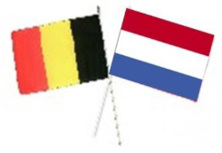
Puppyclass:(6 à 9 months) | 15 €
Young class (9 à 18 months) | 30 €
Intermediate class (15 - 24 months) | 30 €
Open class( 15monthsminimum) | 30 €
Working class (Attach certificate) | 30 €
Champion class( Attach certificate) FCI) | 30 €
Veteran class( 8 yearsminimum)) | 15 € |  | This document must be sent to :  Preyse Marie-Paule  1, trieu Planquart  7730 Saint-Léger (B)  Mail: mp.preyse@hotmail.com  **** : belongs to the producer and exhibited by him as such- with CAC  http://www.chiens-de-saint-hubert.be
Breederclass(15 months minimum) **** | 30 €
Fun Class (not forthe CAC) | 15 €
Breeding group (dad or mom with at least 3 descendants) | Free
Couple class (to the same owner) | Free
Group class (3 dogs minimum tot he same owner) | Free
Total :

The rules of the Royal Cynological Saint Hubert Society for dogs exhibitions approved by the FCI are in effect for this contest. For foreigners, the payment may be done Saturday before the beginning of the contest (9.30AM)
New bank Account  CBSH - BCSH  IBAN : BE48 1262 1156 2427  Bic : CPHBBE75 | I agree with the terms and conditions  Signature : | Lunch 20 € x .........= ..........  Inscription(s)................................  Total : .......................................

